Educational Beginner’s Language Game

User Guide

**Contents**

1. Hardware and Software requirements
2. Installation
3. Troubleshooting
4. Help and Contact information

If what you’re looking for is not found in this user guide, you can refer to the online help for a thorough guide on how to use the software and more. You can access this by the **[?]** button on the bottom right of the game’s screen.

1. Hardware and Software requirements

**Required Software**

In order to play the game, which uses Flash software, you will need to have downloaded and installed Flash Player 11 or later. Additionally, you will need the Windows XP operating system or later (more details shown below)

* Flash Player 11
* Microsoft Windows XP (32-bit), Windows Server 2003 (32-bit), Windows Server 2008 (32-bit) Windows Vista (32-bit), or Windows 7 (32-bit and 64-bit)

**Required Hardware**

* 2.33GHz or faster x86-compatible processor, or Intel Atom™ 1.6GHz or faster processor for netbooks.
* 128MB of RAM
* 128MB of graphics memory

**2** Installing and running the game

If you have not already installed the game onto your computer, all you need to do is copy the file from the USB, and onto a folder or area of your choice on your computer. This has been shown for you below in three easy steps.

**1.**

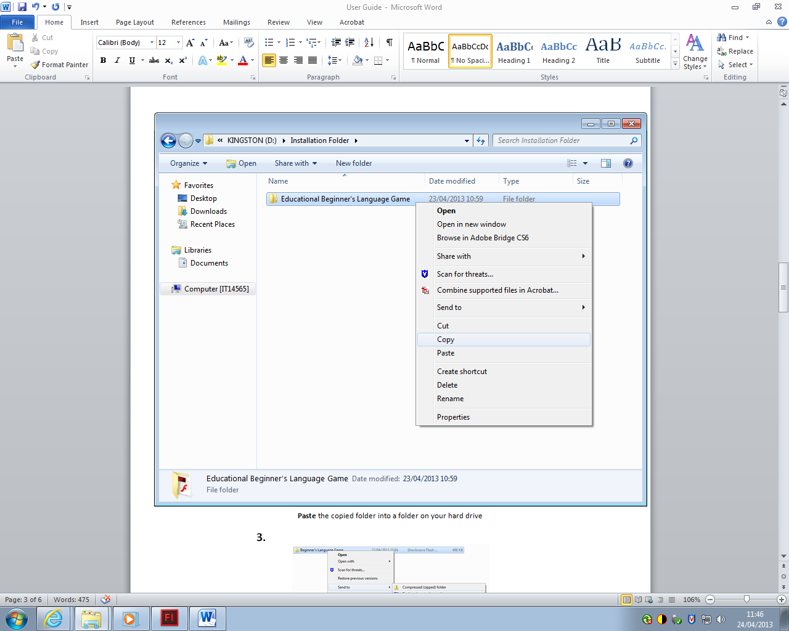

Right-click the file in the USB and select **Copy** from the drop-down menu

**2.**

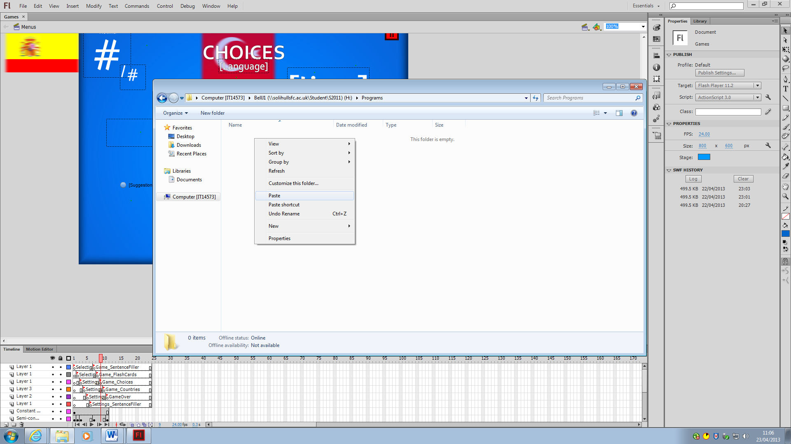

**Paste** the copied folder into a folder or area on your hard drive

**3.**

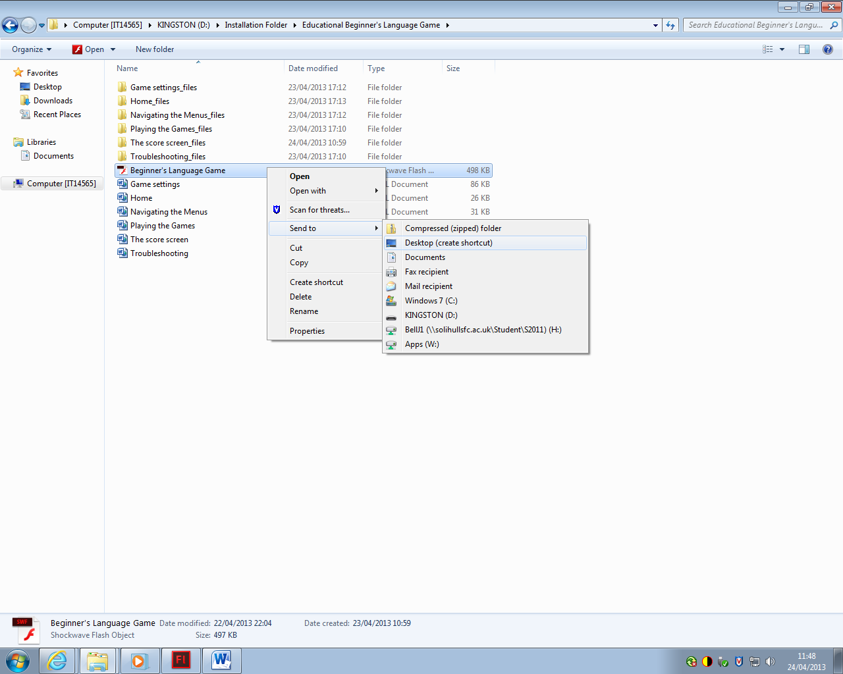

Inside the folder you’ve copied, you will find the Beginner’s Language Game file

Right-click it, go to **Send To** and from the second dropdown menu

Select **Desktop (create shortcut)** to add a shortcut to your desktop

Once you have completed these steps, you are ready to begin playing the game. You can do so by either **Opening** the file from its folder, or by clicking the icon which has now been added to your desktop.

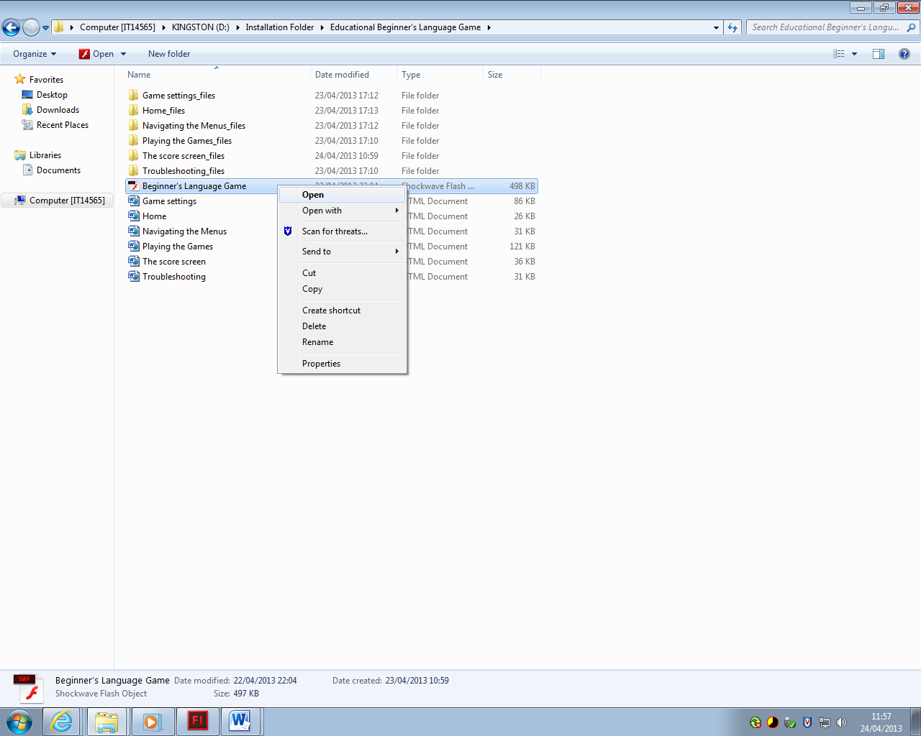

Click **Open** to find the file begin playing

**3** Troubleshooting

**Problem**: I can’t find English in the language selection

**Solution**: English is automatically selected as the main language. The language selection screen is where you choose the language that you wish to be tested on, not the language that you speak

**Problem**: Why can’t I play the Countries and Sentence Filler games?

**Solution**: Development for those two games was cut short due to deadlines. There are plans to add them at a later date.

**Problem**: I’m pressing the Play button, but the game isn’t playing

**Solution**: Check to see if all of the combo boxes in the settings screen have been filled. If any of them are left blank, the game will not play.

**Problem**: I’ve answered a question correctly, but the game is telling me that I’ve got it wrong.

**Answer**: This could be caused by a few problems.

1. The game does not accept synonyms for the translated word. As far as the game is concerned, there is only one answer for every word. For example, bueno could be “good” or “great”, but will only accept one particular answer, such as “good”, even though “great” is technically correct.
2. The problem could have been caused by you using the incorrect character for a word. If the English word is “day” and you answer “dia”, the game will tell you that you are incorrect. You will need to use the correct form of the letter “i” and type “día”.

**Problem:** The translator is telling me that the word is not found. Why?

**Solution:** This could be caused by a few things - either the word was spelt wrong, an invalid input was typed, or the word does not exist in our database. You can check all of the words stored in our database in the list of words display below the translation box

**Problem:** I’m clicking the online help button, but nothing is opening.

**Solution**: Check to see if the help has opened in the background on your main internet browser. The online help does not always appear as a pop-up. Alternatively, this could be caused by the missing files in your installation folder. Make sure that when installing, you copied over the online help files found in the same folder as the game. These need to be in the same folder as the .swf file (the game itself)

**4** Help and Contact Information

If the troubleshooting didn’t help you, or if you have any other problems, you can contact us to receive help for one of our staff.

**Phone**: 555-364-9001

**Email**: [jbell@gmail.co.uk](mailto:jbell@gmail.co.uk)

Additionally, you can visit our forums at [www.willmakegamesformoney.com/forum](http://www.willmakegamesformoney.com/forum) for help and support from our staff and the community.

If what you’re looking for is not found in this user guide, you can refer to the online help for a thorough guide on how to use the software and more. You can access this by the **[?]** button on the bottom right of the game’s screen.